ParkSense: AI-Based Smart Parking and Safety Detection System Using Computer Vision

of

Bachelor of Technology
in The Department of ECE
Course name with Course code

Submitted by

Bhargavi-2510040057
Aishwarya Reddy - 2510040048
Rishitha – 2510040086
Likitha sai - 2510040019
Under the guidance of



Department of Electronics and Communication Engineering
Koneru Lakshmaiah Education Foundation, Aziz Nagar
Aziz Nagar – 500075
FEB - 2025.
Abstract

Parking management is a major challenge in crowded places such as shopping malls, educational institutions, hospitals, and commercial complexes. Drivers often spend considerable time searching for available parking spaces, resulting in traffic congestion, fuel consumption, and inconvenience. Traditional parking systems generally require manual monitoring or individual sensors to identify vacant spaces. To address these challenges, this project proposes ParkSense, an AI-Based Smart Parking and Safety Detection System using Computer Vision.

The proposed system uses camera feeds and computer vision techniques to identify vehicles and determine whether individual parking spaces are available or occupied. Technologies such as Python, OpenCV, and YOLO are proposed for vehicle detection and parking-space monitoring. Each parking space is mapped using predefined polygon coordinates, and vehicle overlap is used to determine its occupancy status. Signal processing techniques, including frame sampling and temporal smoothing, can help reduce fluctuations in detection results and improve the consistency of parking-status updates.

ParkSense is designed to provide a real-time web dashboard that displays parking availability, occupied spaces, and recommended parking locations. Graph-based pathfinding algorithms, such as Dijkstra's algorithm or A*, can be used to identify a suitable route from the entrance to a recommended free parking space. The proposed system also includes wrong-parking detection and emergency-lane blockage alerts to improve parking safety. Machine learning can further support the prediction of parking demand and future availability using historical occupancy data.

The project integrates concepts from Machine Learning, Signal Processing, and Electronic Circuit Design with computer vision and web development. The intended outcome is a scalable, camera-based parking management solution that can reduce dependence on individual parking sensors and provide drivers with clearer availability and navigation information. The system's detection accuracy, response time, and reliability will be evaluated through testing before its performance can be established.

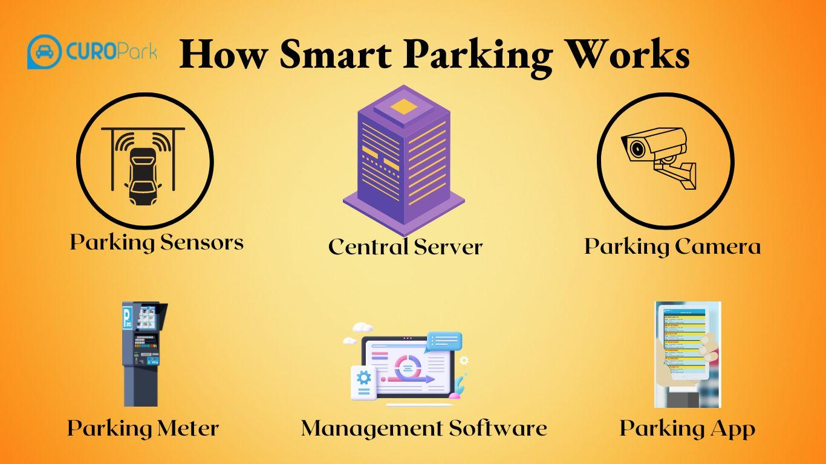
List of Figures

Figure 1. Overall Architecture of the ParkSense System
Figure 2. System Workflow of Camera-Based Smart Parking
Figure 3. Camera-Based Vehicle Detection Using YOLO and OpenCV
Figure 4. Parking Slot Identification Using Polygon Mapping
Figure 5. Parking Slot Occupancy Detection and Classification
Figure 6. Real-Time Parking Availability Dashboard
Figure 7. Recommended Parking Slot and Navigation Route
Figure 8. Wrong-Parking Detection and Alert System
Figure 9. Emergency-Lane Blockage Detection
Figure 10. Parking Occupancy Prediction Using Machine Learning

List of Tables

Table 1. Hardware and System Components Used in ParkSense
Table 2. Software Tools and Technologies
Table 3. Functional Requirements of the Proposed System
Table 4. Vehicle Detection and Parking Slot Classification
Table 5. Signal Processing Techniques for Stable Occupancy Detection
Table 6. Machine Learning Applications in Smart Parking
Table 7. Parking Slot Recommendation and Navigation Algorithms
Table 8. Test Cases and Expected System Behaviour

Table of Contents
- Abstract
- List of Figures
- List of Tables
- INTRODUCTION
  - Background of the Project
  - Problem Statement
  - Objectives
  - Scope of the Project
  - Interdisciplinary Contributions of ML, AECD, and Signal Processing
- METHODOLOGY
  - Proposed System Architecture
  - Camera-Based Vehicle Detection Using YOLO and OpenCV
  - Parking Slot Identification and Occupancy Classification
  - Signal Processing and Temporal Smoothing
  - Machine Learning for Parking Availability Prediction
  - Parking Slot Recommendation and Navigation
  - Wrong-Parking and Emergency-Lane Detection
  - Web Dashboard and Real-Time Communication
- EXPERIMENTS AND IMPLEMENTATION
  - Hardware and Software Requirements
  - Dataset and Video Input
  - Vehicle Detection and Slot Mapping
  - Parking Occupancy Monitoring
  - Dashboard and Navigation Implementation
  - Functional Testing
- RESULTS AND DISCUSSION
  - Vehicle Detection Results
  - Parking Slot Availability
  - Signal Processing Performance
  - Machine Learning Applications
  - System Limitations
- CONCLUSION AND FUTURE WORK
- References

1. INTRODUCTION

1.1 Background of the Project

Parking management is an important challenge in shopping malls, colleges, hospitals, offices, and other public places. Drivers often spend considerable time searching for an available parking space. This can lead to traffic congestion, unnecessary fuel consumption, and inconvenience. In addition, improper parking and vehicles blocking emergency lanes can create safety concerns.

ParkSense: AI-Based Smart Parking and Safety Detection System Using Computer Vision is proposed to make parking management more efficient through camera-based monitoring and artificial intelligence. The system uses a camera feed to observe a parking area and identify vehicles. Computer vision techniques are used to detect vehicles, while predefined parking-slot regions help determine whether each slot is occupied or available.

The proposed system uses Python, OpenCV, and the YOLO object-detection model for processing video frames and identifying vehicles. Each parking space is represented by a predefined polygon in the camera view. By analysing the overlap between detected vehicles and these regions, the system classifies parking spaces as occupied or free.

Signal processing concepts are relevant to the system because video is processed as a sequence of frames. Sampling selected frames and applying temporal smoothing, such as majority voting across recent frames, can help reduce false changes in parking status caused by temporary detection errors.

The system is designed to display parking information through a web-based dashboard. The dashboard can present the number of available and occupied spaces and help users identify a suitable free slot. Graph-based pathfinding algorithms, such as Dijkstra's algorithm or A*, can be used to recommend a route to the selected parking space.

ParkSense also proposes safety-related features, including the identification of incorrect parking and the detection of vehicles blocking emergency lanes. Machine learning may additionally be used to analyse historical parking information and estimate future parking availability. These features are intended to extend the system beyond basic slot detection.

1.2 Problem Statement

Traditional parking systems may require drivers to search manually for vacant spaces. In many parking areas, users do not receive accurate, real-time information about slot availability. This increases the time spent searching for parking and may contribute to congestion within the parking facility.

Manual monitoring can also make it difficult to identify incorrect parking and vehicles obstructing emergency routes. Installing individual sensors in every parking bay may require additional hardware, installation, and maintenance.

Therefore, there is a need for a camera-based parking management system that can automatically analyse video, identify vehicles, estimate parking-slot occupancy, update availability information, and guide users towards suitable spaces.

The proposed ParkSense system addresses this problem by combining computer vision, video-frame processing, a real-time dashboard, and graph-based navigation. Its performance must be evaluated through suitable parking videos, test cases, and measurements before the proposed accuracy and response-time targets can be considered achieved.

1.3 Objectives

The main objectives of the ParkSense project are:

To develop a camera-based approach for monitoring a parking area.

To detect vehicles in video frames using the YOLO object-detection model and OpenCV.

To represent parking spaces using predefined polygon regions.

To classify parking spaces as occupied or available based on vehicle detections and overlap with the defined regions.

To use frame sampling and temporal smoothing to reduce unstable changes in occupancy status.

To display parking availability information through a web-based dashboard.

To recommend a suitable available parking space and calculate a route using graph-based pathfinding.

To explore the detection of incorrect parking and vehicles blocking emergency lanes.

To investigate the use of historical parking data for predicting future parking availability.

To evaluate the system using suitable video inputs, functional test cases, and performance measurements.

1.4 Scope of the Project

The scope of ParkSense includes camera-based observation of parking spaces, vehicle detection, parking-slot mapping, occupancy classification, availability display, and route recommendation. The proposed system can accept an IP camera, CCTV stream, webcam, or recorded video, depending on the available setup.

The computer vision module is intended to detect vehicles and compare their positions with predefined parking-slot regions. The resulting occupancy information can be processed and displayed on a dashboard. A backend service can manage parking information and communicate updates to the frontend using real-time communication methods such as WebSockets.

The project also considers additional capabilities, including parking-violation detection, emergency-lane obstruction alerts, parking statistics, and machine-learning-based availability prediction. These capabilities require suitable implementation and testing before they can be reported as completed features.

The proposed design aims to reduce dependence on individual sensors installed in each parking bay. However, the actual performance will depend on camera placement, lighting conditions, video quality, vehicle occlusion, and the accuracy of slot-region configuration.

The project review identifies a target of at least 95% parking-slot detection accuracy and a response time below two seconds. These are design targets, not confirmed experimental results. They must be validated through testing.

1.5 Interdisciplinary Contributions of ML, AECD, and SP

ParkSense is intended to connect concepts from Machine Learning (ML), Analog and Electronic Circuit Design (AECD), and Signal Processing (SP).

1.5.1 Machine Learning (ML)

Machine learning contributes to the project through object detection and the proposed analysis of parking data. The YOLO model is used in the design to identify vehicles in video frames. The detected vehicle locations are then compared with the predefined parking-slot regions to estimate occupancy.

Historical parking information may also be used to investigate future availability prediction and peak-hour parking trends. These predictive functions would require suitable data, model development, and performance evaluation.

1.5.2 Analog and Electronic Circuit Design (AECD)

The camera-based design primarily relies on video input and software processing. An AECD contribution should therefore be demonstrated through a clearly defined electronic circuit relevant to the project, such as a suitable power-supply or signal-conditioning circuit for an additional hardware interface, if required by the final implementation.

The circuit components, design calculations, simulation, and measured results must be documented only after the actual circuit has been selected and tested. The current project review does not specify a completed AECD circuit; this component must be confirmed and incorporated into the final project if required by the course.

1.5.3 Signal Processing (SP)

Signal processing contributes to the handling of video as a sequence of frames. Instead of relying on every frame, the system can process selected frames from the video stream. Temporal smoothing can then be applied to recent occupancy predictions.

For example, majority voting across several recent frames can help prevent a parking space from repeatedly changing between occupied and available because of a temporary detection error. These techniques can improve the stability of displayed parking information, although their actual effectiveness must be measured experimentally.

By combining these disciplines, ParkSense aims to provide a practical approach to parking monitoring, availability display, and navigation while allowing further development of safety and prediction features.

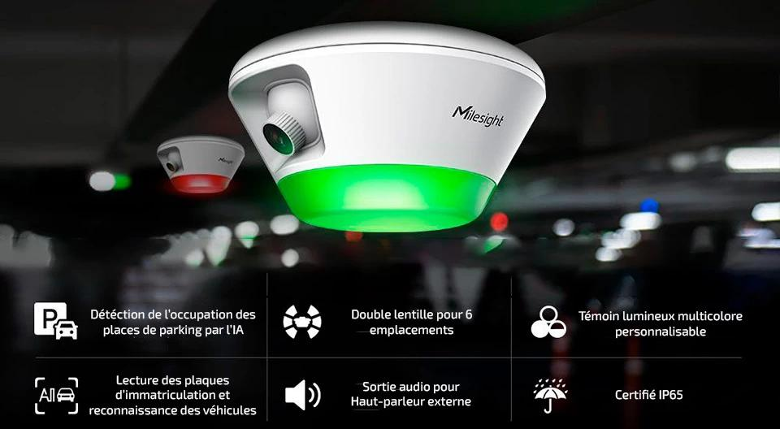

2. METHODOLOGY
- 2.1 System Architecture
- ParkSense is designed as a camera-based smart parking system that combines computer vision, video processing, parking-slot occupancy classification, backend communication, and a web-based dashboard. The system receives video from a camera or a recorded video file and processes the frames to identify vehicles and determine parking-slot availability.
- The proposed architecture consists of the following major modules:
- Video Input Module: Receives video from an IP camera, CCTV camera, webcam, or recorded video file.
- Vehicle Detection Module: Uses YOLO and OpenCV to detect vehicles in the selected video frames.
- Parking-Slot Mapping Module: Represents each parking space using a predefined polygon region.
- Occupancy Classification Module: Compares vehicle detections with the parking-slot regions to estimate whether each slot is occupied or available.
- Signal Processing Module: Processes selected video frames and applies temporal smoothing to reduce unstable occupancy predictions.
- Backend Module: Manages parking information and provides communication between the detection system and the dashboard. FastAPI and a database such as SQLite or PostgreSQL are proposed technologies.
- Navigation Module: Uses a graph representation of the parking area and a pathfinding algorithm to recommend a route to an available slot.
- Dashboard Module: Displays parking availability and related information to users through a web interface.
- The overall process begins with video input and ends with the display of parking availability and, where implemented, route recommendations.
- Figure 2.1: Proposed System Architecture of ParkSense
- Insert an architecture diagram showing: Camera/Video Input → YOLO Vehicle Detection → Parking-Slot Mapping → Occupancy Classification → Backend and Database → Web Dashboard and Navigation.
- 2.2 Vehicle Detection Using YOLO and OpenCV
- Vehicle detection is an important stage of the ParkSense system. The proposed design uses the YOLO object-detection model to identify vehicles in video frames. OpenCV is used to read video input, extract frames, and support image-processing operations.
- The process involves the following steps:
- Obtain a video stream or recorded parking-area video.
- Read the video using OpenCV.
- Extract selected frames for processing.
- Pass each selected frame to the YOLO detection model.
- Obtain the detected vehicle classes, bounding boxes, and confidence scores.
- Use the detected vehicle locations in the parking-slot occupancy module.
- A bounding box represents the approximate location of a detected vehicle in a frame. Its position can be compared with the predefined parking-slot regions to estimate whether a vehicle occupies a particular space.
- The quality of detection depends on factors such as lighting, camera position, image resolution, vehicle overlap, and partial obstruction. Therefore, the detection module must be evaluated using suitable parking videos.
- Figure 2.2: Vehicle Detection Using YOLO and OpenCV
- Insert an actual screenshot showing a parking video frame with vehicle bounding boxes, if available.
- 2.3 Parking-Slot Identification and Occupancy Classification
- To identify individual parking spaces, the parking area is divided into predefined regions. Each parking space is represented by a polygon whose coordinates correspond to its location in the camera image.
- These polygon regions must be configured according to the camera view. When a video frame is processed, the system obtains the bounding boxes of detected vehicles and compares them with the defined parking-slot regions.
- The occupancy classification process is as follows:
- Define the polygon coordinates for each parking space.
- Detect vehicles in the current video frame.
- Determine the overlap between each detected vehicle and the parking-slot regions.
- Compare the overlap with a selected threshold.
- Classify each slot as occupied or available based on the classification rule.
- Update the parking-status information for display.
- Intersection over Union (IoU) is one possible measure for evaluating the overlap between two regions. It is calculated as:
- IoU = Area of Intersection / Area of Union
- A higher overlap indicates that the two regions cover a larger common area. However, the final occupancy decision also depends on the chosen threshold and the geometry of the parking spaces.
- The number of occupied and available slots can then be calculated from the individual slot classifications.
- Figure 2.3: Parking-Slot Polygon Mapping and Occupancy Classification
- Insert an actual image showing predefined parking-slot polygons and vehicle detections, if available.
- 2.4 Signal Processing and Temporal Smoothing
- Signal processing concepts are used to improve the stability of parking-slot status information. Since a video consists of consecutive frames, the detected occupancy of a slot may change temporarily because of vehicle movement, partial obstruction, lighting changes, or incorrect detections.
- Processing every frame may also increase computational requirements. Therefore, the proposed system can process selected frames at a suitable sampling rate. The project review suggests processing approximately 2–5 frames per second as a design approach.
- Temporal smoothing can be applied to the occupancy predictions obtained from recent frames. One possible technique is majority voting, in which the most frequently predicted status within a selected group of frames becomes the final status.
- For example, suppose a parking slot is classified as occupied in four out of five recent frames and available in one frame. Majority voting would classify the slot as occupied for that group of frames.
- The procedure is as follows:
- Read the incoming video.
- Select frames at the chosen processing rate.
- Perform vehicle detection and slot classification on each selected frame.
- Store the recent occupancy predictions for each slot.
- Apply majority voting to determine a stable status.
- Update the dashboard with the resulting occupancy information.
- This method is intended to reduce flickering in the displayed parking status. Its effectiveness should be measured by comparing the raw predictions with the smoothed predictions.
- Figure 2.4: Temporal Smoothing of Parking-Slot Status
- Insert a flowchart showing frame sampling → vehicle detection → slot classification → majority voting → final slot status.
- 2.5 Machine Learning for Parking Availability Prediction
- Machine learning is a major component of the ParkSense design. The YOLO model is proposed for detecting vehicles in video frames, while historical parking data may be used for future availability prediction.
- Historical data could include parking occupancy over time, the number of occupied spaces, the number of available spaces, and peak-hour usage patterns. After suitable data collection and preparation, a predictive model could be trained to estimate future parking demand or availability.
- The proposed process consists of:
- Collect parking-occupancy records over time.
- Clean and organize the historical data.
- Identify useful features, such as time of day and previous occupancy.
- Prepare training and testing datasets.
- Train a suitable machine-learning model.
- Evaluate predictions using appropriate performance measures.
- Display predicted availability when the prediction module is implemented.
- The historical prediction module is an extension of the basic real-time detection system. Its performance depends on the availability and quality of historical data. A trained prediction model and measured results must be provided before this functionality can be claimed as completed.
- 2.6 Parking-Slot Recommendation and Navigation
- ParkSense proposes a navigation feature to help users reach an available parking space. The parking area can be represented as a graph containing nodes and edges.
- Nodes may represent intersections, turning points, entrances, exits, and parking locations. Edges represent the paths connecting these points. Each edge can be assigned a cost based on distance or another suitable measure.
- When a user requests a parking space, the system identifies available slots and selects a suitable destination. A pathfinding algorithm can then calculate a route from the entrance or the user's current location within the parking map to the selected slot.
- The proposed algorithms include:
- Dijkstra's Algorithm: Finds a shortest path when edge costs are non-negative.
- A Algorithm:* Uses path cost and a heuristic estimate to search for a route towards the destination.
- The calculated route can be displayed on the dashboard using a parking map. The route recommendation must be connected to the actual parking-status data to avoid directing users towards occupied spaces.
- Figure 2.5: Parking-Slot Recommendation and Route Navigation
- Insert an actual parking-map screenshot showing an available slot and its route, if available.
- 2.7 Wrong-Parking and Emergency-Lane Detection
- The project review proposes additional safety features for identifying incorrect parking and vehicles blocking emergency lanes.
- For wrong-parking detection, designated parking regions and restricted areas can be defined on the camera view. Vehicle detections can then be compared with these regions to identify possible parking violations.
- Similarly, an emergency lane can be represented as a predefined restricted region. If a detected vehicle occupies this region, the system may generate a warning.
- The general procedure is:
- Define parking regions and restricted areas.
- Detect vehicles in the video frame.
- Compare vehicle locations with the defined regions.
- Apply the selected violation-detection rules.
- Generate an alert when a violation is identified.
- Display the alert through the dashboard, if the alert module is implemented.
- These functions require appropriate region definitions and testing under different conditions. They are proposed capabilities and should be described as implemented features only if they have been developed and verified.
- 2.8 Web Dashboard and Real-Time Communication
- The web dashboard is designed to present parking information in a clear and accessible format. The proposed frontend uses React, while the backend may use FastAPI to process requests and communicate parking-status updates. WebSockets can support real-time communication between the backend and frontend.
- The dashboard may display:
- Total number of parking spaces.
- Number of occupied spaces.
- Number of available spaces.
- Individual parking-slot status.
- Recommended parking destination and route.
- Safety alerts, when supported.
- Historical parking statistics, when available.
- The backend can store relevant information in SQLite or PostgreSQL. The frontend can request or receive updated occupancy information and refresh the display.
- The proposed technology stack includes Python, OpenCV, YOLOv8, PyTorch, React, FastAPI, WebSockets, SQLite or PostgreSQL, and NetworkX for graph-related operations.
- The exact components used in the final implementation should be documented according to the actual source code and development environment.
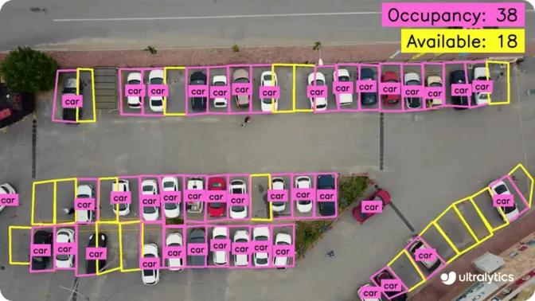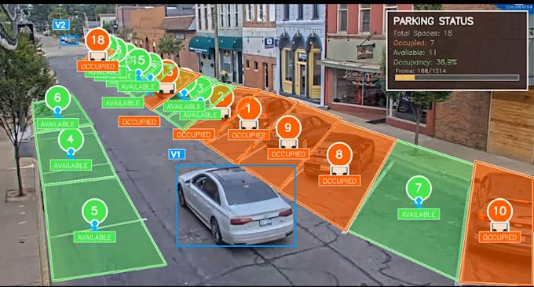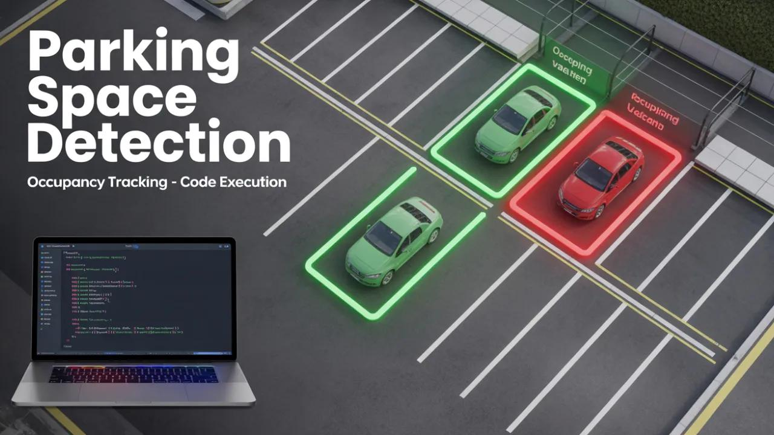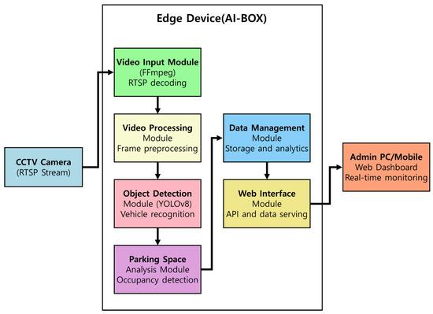

3.EXPERIMENTS AND IMPLEMENTATION

3.1 Hardware and Software Requirements

The ParkSense system is designed to use a camera-based input source and software modules for vehicle detection, parking-slot classification, and visualization. The exact hardware and software requirements depend on the final implementation.

3.1.1 Hardware Requirements

The proposed hardware requirements are:

Computer or Laptop: Used to execute the vehicle-detection model, process video frames, and run the application.

Camera or Video Source: An IP camera, CCTV camera, webcam, or recorded video provides the parking-area footage.

Network Connection: Required when a network camera or remote dashboard communication is used.

Display: Used to view the parking dashboard and detection results.
S. No. | Software/Technology | Purpose
1 | Python | Main programming language for video processing and backend operations
2 | OpenCV | Video reading, frame extraction, and image-processing operations
3 | YOLOv8 | Vehicle detection in video frames
4 | PyTorch | Deep-learning framework used by the detection model
5 | React | Proposed frontend for the parking dashboard
6 | FastAPI | Proposed backend API framework
7 | WebSockets | Proposed real-time communication between backend and frontend
8 | SQLite/PostgreSQL | Proposed storage for parking information
9 | NetworkX | Graph creation and pathfinding support

The system aims to use camera footage instead of requiring a separate sensor in every parking bay. The final hardware configuration should be documented according to the equipment actually used during testing.

3.1.2 Software Requirements

Note: These technologies are listed in the project design. The final report should identify which ones were actually installed and used.

3.2 Dataset and Video Input

The system requires video footage of a parking area to identify vehicles and estimate parking-slot occupancy. The input may be obtained from a webcam, a suitable camera stream, or a recorded video file.

For initial testing, recorded video is useful because the same input can be processed repeatedly. This allows the detection output to be compared across different configurations.

The project review identifies the PKLot and CNRPark-EXT datasets as possible resources for validation. Their suitability depends on the format of the data and the evaluation method selected.

The video input procedure is as follows:

Select a suitable parking-area video.

Load the video using OpenCV or connect to the supported camera source.

Read frames from the video.

Select frames for processing at the chosen sampling rate.

Send the selected frames to the vehicle-detection module.

Record the detection output for further occupancy analysis.

Different lighting conditions, camera angles, and vehicle arrangements should be considered when evaluating the system.

3.3 Vehicle Detection and Parking-Slot Mapping

Vehicle detection and parking-slot mapping are the main steps used to determine parking occupancy.

First, the video frame is passed to the YOLO detection model. The model identifies vehicles and provides their approximate locations using bounding boxes. These detections are then compared with the predefined polygon regions representing individual parking spaces.

The implementation procedure is:

Load the selected parking video.

Read a frame from the video.

Perform vehicle detection using the selected YOLO model.

Obtain the bounding boxes of detected vehicles.

Load or define the coordinates of the parking-slot polygons.

Calculate the overlap between vehicle detections and slot regions.

Apply the selected classification threshold.

Display or record the estimated occupancy of each slot.

The slot-mapping configuration is important because the polygons must match the parking spaces visible in the camera view. Incorrect polygon coordinates can lead to incorrect occupancy classifications.

Figure 3.1: Vehicle Detection and Parking-Slot Mapping

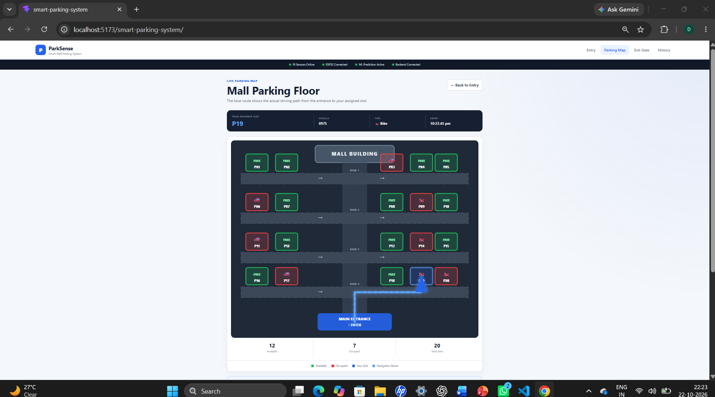3.4 Parking Occupancy Monitoring

After vehicle detection and slot mapping, the system estimates whether each parking space is occupied or available.

The occupancy-monitoring process uses the detections from the current frame and the predefined parking-slot regions. The system applies its selected overlap and classification rules to determine the status of each slot.

If temporal smoothing is implemented, the system also considers recent occupancy predictions before updating the final status. This can reduce temporary changes caused by inconsistent detections.

The following information can be recorded during testing:

Total number of defined parking spaces.

Number of spaces classified as occupied.

Number of spaces classified as available.

Actual occupancy status used as the reference.

Incorrect occupancy classifications.

Time taken to process the selected frame.

The total number of slots should satisfy:

Total Slots = Occupied Slots + Available Slots

This relationship can be used as a basic consistency check for the occupancy results.

3.5 Dashboard and Navigation Implementation

The proposed dashboard provides a user interface for viewing parking availability and related information. The frontend is planned using React, while the backend can provide occupancy information through API requests or WebSocket communication.

The implementation can be divided into the following tasks:

Create a dashboard interface.

Display the total number of parking spaces.

Show occupied and available slot counts.

Display the status of individual parking spaces.

Connect the frontend to the backend.

Update the displayed information when new occupancy data becomes available.

Integrate a parking map and route recommendation if navigation is implemented.

For navigation, the parking area can be represented as a graph. A pathfinding algorithm such as Dijkstra's algorithm or A* can calculate a route to a selected available space.

The dashboard and navigation functions should be tested with actual occupancy information to confirm that the displayed status and recommended destination are consistent.

Figure 3.2: ParkSense Dashboard
Test Case | Input or Condition | Expected Result
TC1 | Video containing visible vehicles | The detection model attempts to identify vehicles
TC2 | Vehicle located within a defined parking space | The corresponding slot is classified according to the occupancy rule
TC3 | Empty parking space | The slot is classified as available when no qualifying vehicle detection overlaps it
TC4 | Repeated occupancy predictions across frames | Temporal smoothing produces a stable status when implemented
TC5 | Multiple occupied and available spaces | Occupied and available counts are updated consistently
TC6 | Selected available parking destination | A route is generated when the navigation module is implemented
TC7 | Vehicle detected in a configured restricted area | A warning is generated when violation detection is implemented
TC8 | New occupancy information received by the dashboard | The display updates when backend communication is implemented

Insert a screenshot of your actual dashboard, if available.

Figure 3.3: Parking-Slot Route Recommendation
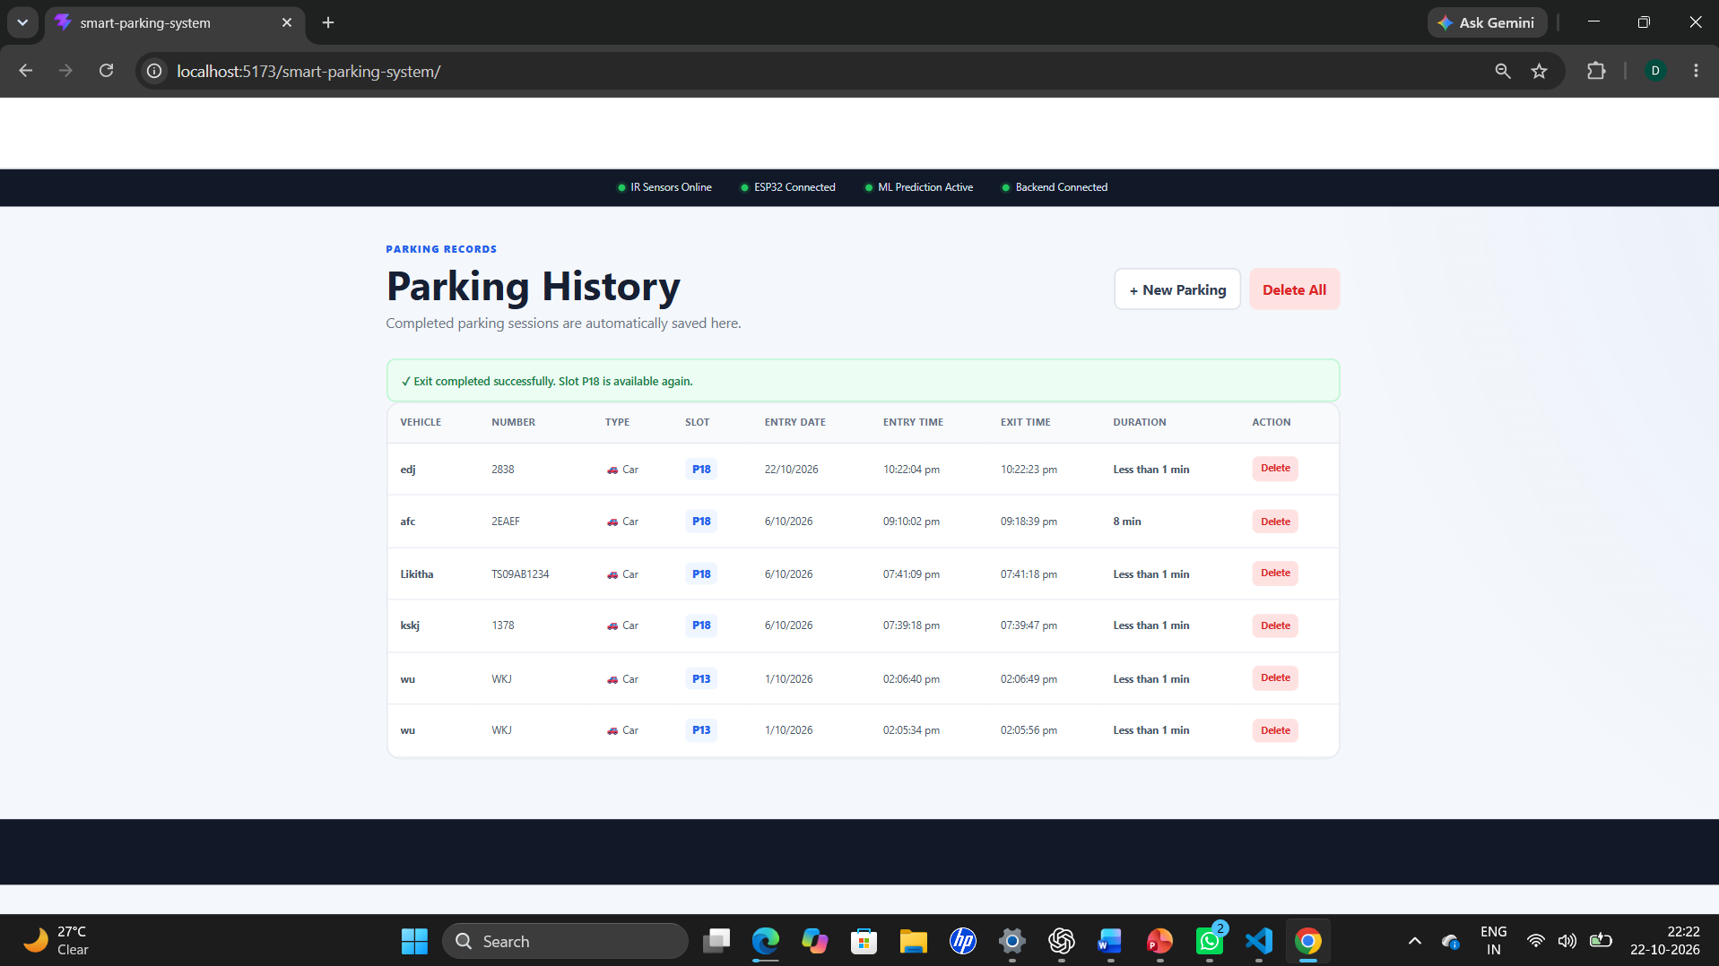

Insert a screenshot of the actual route-navigation output, if implemented.

3.6 Functional Testing

Functional testing is required to verify whether the main system modules behave as expected. The following test cases can be used to evaluate the ParkSense design.

The expected results in this table describe the intended behaviour of the system. Actual outcomes should be recorded after executing each test.

The testing process should also consider difficult conditions, such as poor lighting, partially hidden vehicles, overlapping detections, and changes in camera position.

A complete evaluation should record the actual result for each test case and identify whether the test passed or failed. This provides evidence for the results and discussion presented in the next chapter.

4. RESULTS AND DISCUSSION

4.1 Vehicle Detection Results
- The ParkSense project is designed to use the YOLO object-detection model and OpenCV to identify vehicles in parking-area video frames. The detected vehicle locations are used to estimate the occupancy status of predefined parking spaces.
- The expected output of this module includes vehicle bounding boxes and detection information for each processed frame. Detection performance may vary depending on lighting conditions, camera position, image quality, and partial obstruction of vehicles.
- The project review specifies a target parking-slot detection accuracy of at least 95%. This value is a design target and must be verified through experiments before it can be reported as the achieved accuracy.
- The following table can be completed after testing.
- Table 4.1: Vehicle Detection Evaluation
- Parameter | - Result
- Video or dataset used | - [Enter the actual video or dataset]
- Total reference vehicle instances | - [Enter measured count]
- Correctly detected vehicles | - [Enter measured count]
- Missed vehicle detections | - [Enter measured count]
- Incorrect vehicle detections | - [Enter measured count]
- Detection accuracy or selected evaluation metric | - [Enter measured result]
- The results should be discussed based on the actual measurements. Any missed or incorrect detections should be analysed to identify possible improvements.

4.2 Parking-Slot Availability Results
- The parking-slot classification module uses predefined polygon regions and detected vehicle locations to estimate whether parking spaces are occupied or available.
- The system is intended to display the number of occupied and available spaces. The status of each slot can be compared with the actual parking condition to evaluate classification performance.
- The following relationship is used to check the consistency of the slot counts:
- Total Parking Slots = Occupied Slots + Available Slots
- Table 4.2: Parking-Slot Occupancy Evaluation
- Parameter | - Result
- Total defined parking spaces | - [Enter actual count]
- Correctly classified occupied spaces | - [Enter measured count]
- Correctly classified available spaces | - [Enter measured count]
- Incorrectly classified spaces | - [Enter measured count]
- Overall slot-classification accuracy | - [Calculate from test data]
- The system's performance should be tested with empty, partially occupied, and highly occupied parking areas. Incorrect classifications may occur when vehicles are partially hidden, detections overlap, or the parking-slot polygons are not accurately configured.
- Actual screenshots of the processed video and parking-slot status should be included to demonstrate the system's output.

4.3 Signal Processing Performance
- Signal processing contributes to video-frame selection and the stabilization of parking-slot status. The proposed system can process selected frames at approximately 2–5 frames per second and apply majority voting across recent occupancy predictions.
- The purpose of temporal smoothing is to reduce unnecessary changes in the displayed slot status when individual frame predictions are inconsistent.
- The performance of this method can be evaluated by comparing the occupancy predictions before and after smoothing. The evaluation should use the same video input and reference occupancy labels.
- Table 4.3: Signal Processing Evaluation
- Parameter | - Result
- Frame-processing rate | - [Enter actual rate]
- Number of frames evaluated | - [Enter measured count]
- Occupancy errors before smoothing | - [Enter measured count]
- Occupancy errors after smoothing | - [Enter measured count]
- Processing time per frame | - [Enter measured time]
- If the measured errors decrease after smoothing, the result provides evidence that the method improves occupancy stability for the tested video. If the errors do not decrease, the smoothing window and classification rules may need further adjustment.
- These measurements should be collected experimentally rather than estimated.

4.4 Machine Learning and Navigation Features
- The ParkSense design includes vehicle detection using YOLO and proposes additional machine-learning and navigation capabilities.
- Vehicle detection can be evaluated using suitable labelled parking videos. Possible measures include precision, recall, and other appropriate detection metrics.
- Historical parking information may also be used to investigate future availability prediction. However, the predictive module requires suitable historical data, a trained model, and a separate evaluation before its performance can be reported.
- The proposed navigation module represents the parking area as a graph and uses a pathfinding algorithm, such as Dijkstra's algorithm or A*, to identify a route to an available space.
- Table 4.4: Evaluation of Additional Features
- Feature | - Evaluation Method | - Status
- YOLO vehicle detection | - Compare detections with labelled reference data | - [Enter actual status]
- Future parking availability prediction | - Evaluate predictions against actual occupancy | - [Enter actual status]
- Route recommendation | - Verify the generated route on the parking map | - [Enter actual status]
- Wrong-parking detection | - Test vehicles against configured restricted regions | - [Enter actual status]
- Emergency-lane obstruction alert | - Test vehicles within a defined emergency-lane region | - [Enter actual status]
- Real-time dashboard updates | - Verify that new occupancy information is displayed | - [Enter actual status]
- The status of each feature must reflect the actual implementation and test results. Proposed features should not be described as successfully implemented without supporting evidence.

4.5 Limitations and Discussion
- The performance of ParkSense depends on several factors. Camera placement and video quality affect vehicle detection and parking-slot mapping. Poor lighting, partial vehicle obstruction, and overlapping vehicles may lead to incorrect occupancy classifications.
- The predefined parking-slot polygons must also match the camera view. If the camera is moved or the parking layout changes, the polygon coordinates may need to be updated.
- Processing video frames requires computational resources. The selected frame rate and detection model should therefore be evaluated to balance processing speed and detection performance.
- Temporal smoothing can reduce temporary status changes, but it may introduce a delay when a vehicle enters or leaves a parking space. The smoothing window must be selected carefully.
- Navigation depends on an accurate parking-area graph and reliable occupancy information. Similarly, historical availability prediction requires sufficient and representative data.
- The project review identifies at least 95% parking-slot accuracy and a response time below two seconds as performance targets. These targets must be validated experimentally. The final discussion should compare the measured results against them and explain any differences.
- Overall, the project provides a framework for combining computer vision, video processing, parking-status visualization, and navigation. Further implementation and testing are necessary to establish its actual performance and reliability.

5. CONCLUSION AND FUTURE WORK

5.1 Conclusion

ParkSense: AI-Based Smart Parking and Safety Detection System Using Computer Vision is proposed to improve parking management through camera-based vehicle detection and parking-slot occupancy monitoring. The system combines computer vision, signal processing concepts, and a web-based dashboard to provide information about parking availability.

The proposed approach uses YOLO and OpenCV to detect vehicles in video frames. Predefined parking-slot regions are used to estimate whether individual spaces are occupied or available. Frame sampling and temporal smoothing can help reduce unstable changes in occupancy status. A dashboard can present the parking information, while graph-based pathfinding algorithms can be used to recommend routes to available spaces.

The project also considers additional features, such as wrong-parking detection, emergency-lane obstruction alerts, and machine-learning-based prediction of future parking availability. These features can extend the system's usefulness when they are implemented and validated.

The project review establishes performance targets of at least 95% parking-slot detection accuracy and a response time below two seconds. These targets require experimental verification before the system's performance can be conclusively assessed.

In conclusion, ParkSense provides a framework for developing a smart parking solution using computer vision and software-based monitoring. Further implementation, testing, and performance evaluation are necessary to establish its accuracy, reliability, and suitability for real-world parking environments.

5.2 Future Work

The following improvements can be considered in future versions of ParkSense:

Improved Vehicle Detection: Evaluate and optimize the detection model under different lighting conditions, camera angles, and vehicle arrangements.

Real-Time Performance: Improve frame-processing efficiency and measure the time required to update parking availability.

Parking Availability Prediction: Develop and evaluate a machine-learning model using historical parking-occupancy data.

Advanced Navigation: Integrate the parking map with a reliable pathfinding algorithm to guide users to available spaces.

Safety Monitoring: Develop and test wrong-parking detection and emergency-lane obstruction alerts.

Dashboard Improvements: Provide clearer parking maps, occupancy statistics, and real-time status updates.

Database Integration: Store parking records to support historical analysis and future prediction.

Extended Testing: Evaluate the system using additional parking videos and suitable datasets, including PKLot and CNRPark-EXT where appropriate.

Robustness Testing: Study the effects of shadows, occlusion, camera movement, and changes in lighting on detection accuracy.

AECD Integration: Select and document a relevant electronic circuit, if required by the interdisciplinary project, and include its design calculations, simulation, and experimental results.

These improvements can help make ParkSense more accurate, efficient, and suitable for practical parking management.

REFERENCES
[1] G. Jocher, A. Chaurasia, and J. Qiu, “Ultralytics YOLO,” Ultralytics. Available: https://github.com/ultralytics/ultralytics
[2] OpenCV, “OpenCV Documentation.” Available: https://docs.opencv.org/
[3] PyTorch, “PyTorch Documentation.” Available: https://pytorch.org/docs/
[4] FastAPI, “FastAPI Documentation.” Available: https://fastapi.tiangolo.com/
[5] React, “React Documentation.” Available: https://react.dev/
[6] NetworkX, “NetworkX Documentation.” Available: https://networkx.org/documentation/
[7] Scikit-learn, “Scikit-learn User Guide.” Available: https://scikit-learn.org/stable/user_guide.html
[8] PKLot Dataset, “Parking Lot Database.” Verify the dataset source and citation corresponding to the version used in the project.
[9] CNRPark-EXT Dataset, “Extended Dataset for Parking Occupancy Detection.” Verify the original publication and dataset source before citing it.
[10] ParkSense Project Review Presentation, “Vision-Based Smart Parking & Safety Detection System,” project review presentation, 2026.

